**Project** | Chinook Music Store Analysis

**INTRODUCTION:** You will explore and analyze the Chinook database to uncover insights and trends related to the digital music store. This open-ended project encourages your creativity and critical thinking in formulating questions and queries!



Imagine you are a data analyst at Chinook Music Store. Your task is to explore the store's database to discover valuable insights about sales, customers, inventory, and overall store performance. Your analysis will help inform business decisions and strategies.

**— Guidelines**

**Explore the Database**

* Familiarize yourself with the tables and relationships in the Chinook database. The schema is attached. Please download
* Use SQL queries to investigate various aspects of the store's data.

**Formulate Questions**

* Develop your own questions to guide your analysis. Consider areas such as sales trends, customer behavior, inventory management, and artist popularity.
* Examples of questions to consider:
  + What are the trends in sales over time?
  + Who are the top customers and what are their purchasing patterns?
  + Which genres or artists are most popular?
  + How does the store's inventory align with sales?

**Perform the Analysis**

* Write and execute SQL queries to answer your questions.
* Use JOINs, aggregations, and subqueries as needed to combine and analyze data from multiple tables.
* Document your queries and findings.

**Present Your Findings**

* Summarize the key insights you discovered through your analysis.
* Provide recommendations based on your findings. How can the store improve sales or customer satisfaction? What inventory changes might be beneficial?

**— Chinook Database Schema**

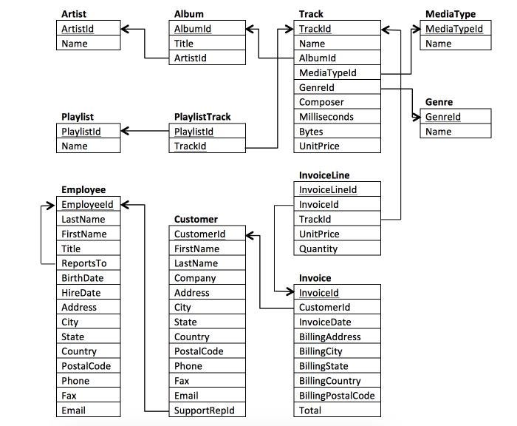

**— Deliverables**

* Please submit a document that includes all your SQL queries and a detailed analysis of your findings.
* Create a slide presentation (e.g., PowerPoint, Google Slides) with the results of the tasks, emphasizing the interpretation of your findings.
  + Take a look at [SlidesGo](https://slidesgo.com/) and [Slides Carnival](https://www.slidescarnival.com/) for fantastic, free slide templates!
* Submit your presentation as a PDF.
* You will prepare a 5-10 minute presentation and submit a recording of your presentation. This practice is valuable for simulating live presentations, a crucial skill in data analytics.

**— Rubric (Total: 20 Points)**

**1. Quality of SQL Queries (10 Points)**

* Excellent (9-10 points): Queries are well-optimized and correctly use advanced SQL features (e.g., joins, subqueries, window functions).
* Good (8 points): Queries correctly retrieve data with effective use of SQL but less optimization or complexity.
* Adequate (5-7 points): Queries are functional but simple, with limited use of advanced SQL features.
* Poor (1-4 points): Queries are incorrect, inefficient, or fail to retrieve the right data.

**2. Depth of Analysis (5 Points)**

* Excellent (5 points): Analysis is comprehensive, with deep insights and clear evidence-based conclusions.
* Good (4 points): Analysis is well-done, with some insightful conclusions and good evidence.
* Adequate (3 points): Analysis covers basic insights with minimal depth.
* Poor (1-2 points): Analysis is superficial or lacking in detail and clarity.

**3. Clarity and Presentation of Findings (5 Points)**

* Excellent (5 points): Findings are presented clearly and professionally, with well-organized documentation.
* Good (4 points): Findings are clearly presented, but with some room for improvement in organization.
* Adequate (3 points): Presentation is understandable but lacks clarity or organization.
* Poor (1-2 points): Findings are poorly presented, difficult to understand, or disorganized.

Have fun, and good luck!